Quadratic functions and Equations

Intro to parabolas

Parabolas intro
Para: beside , bola : balistic , throwing
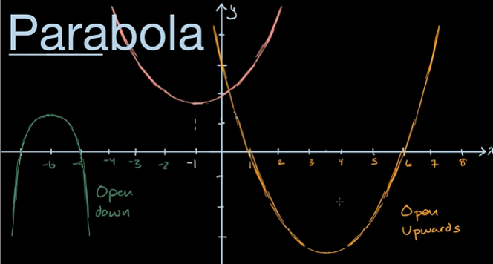
Vertex can be minima or maxima.
You can see symmetry. You have line of symmetry. You can flip a graph so, it fold onto itself.

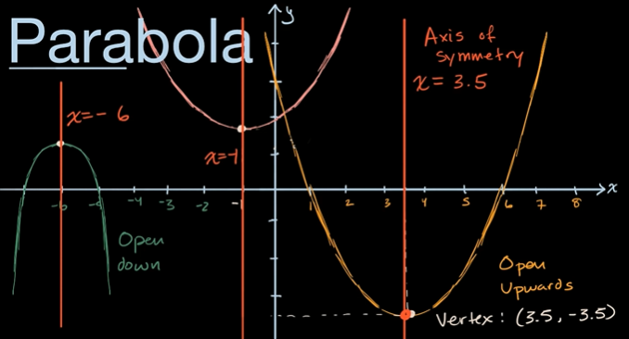

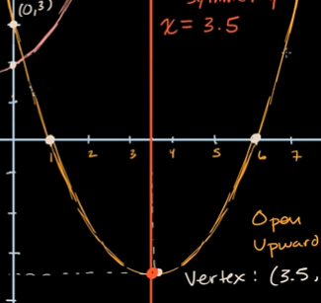
Y- intercept and x-intercept. The x-intercept are symmetric around the axis of symmetry.

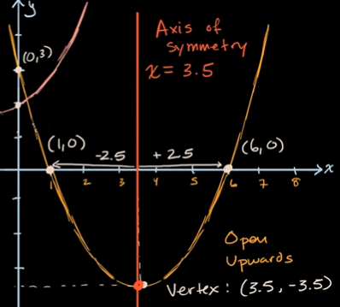
So if you know the Two x-intercepts, then you can take the midpoint to find the axis of symmetry and on the same x-coordinate. You have the vertex which could be maxima or minima.

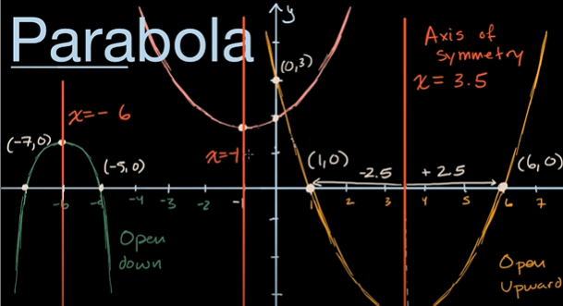

For the pink parabola, its low point is above the x axis, so its not gonna have any x-intercept.
Parabolas are represented by quadratic equations.

Interpreting a parabola in context
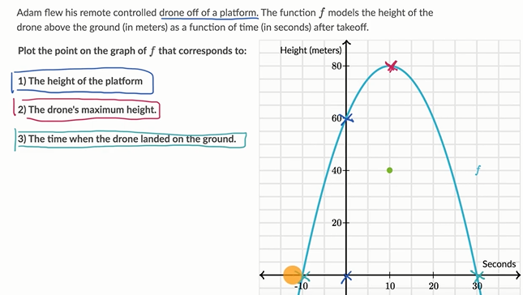

Interpret a quadratic graph
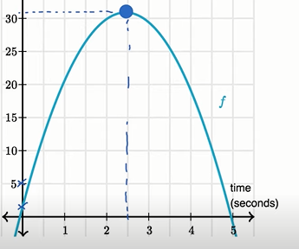

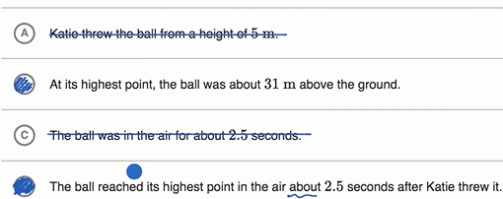

Quadratic word problems (Factored form)
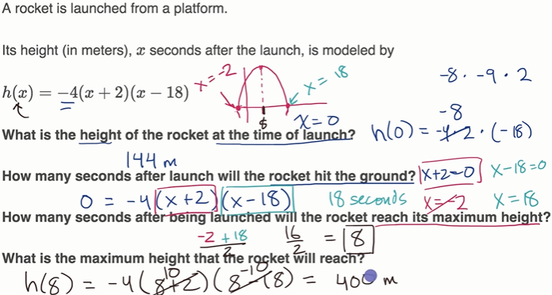

Vertex form introduction
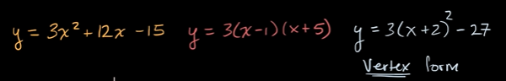
They all are exact same equation, but they are algebraically manipulated.
Standard form, factored form, vertex form.
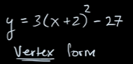
You can say its a upward facing parabola since large value of x, we have large value of y.
Y intercept at 3*4-27=12-27=-15
9=(x+2)^2
(+-) 3 = x+2
x=1 and -5.
since upward, it has a minima at 1+-5/2= -2.
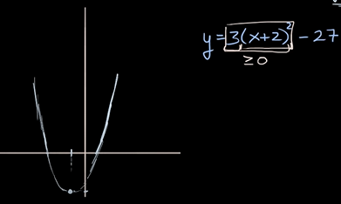
since its a minima,
What is the lowest value for y.
Y= 3(x+2)^2 – 27
lowest value or the most negative value, its when the adding component doesnt exist.

So at x= negative 2, its the lowest point, so minima is at x= -2.
Another trick i think by me is
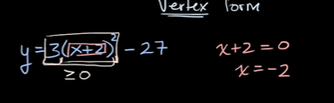
Try putting infinity as x if ans is positive, its upward opening parabola.
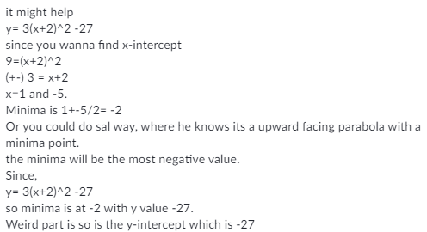

Completing the square method
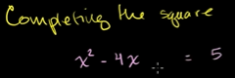

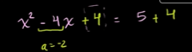

Finding the vertex of a parabola in standard form
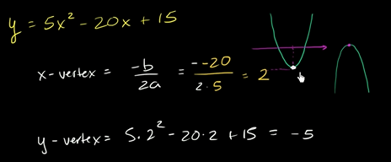

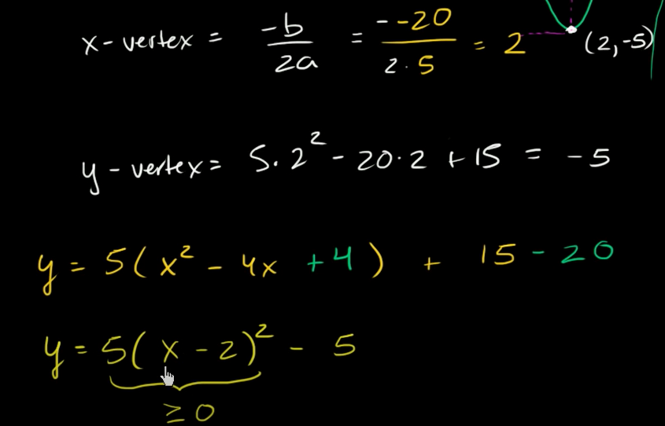

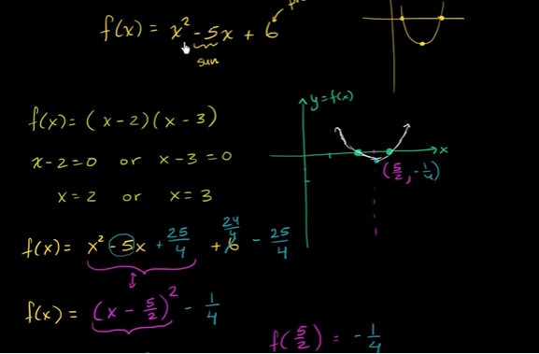
Form and features of quadratic functions

